Ideation Phase

Brainstorm & Idea Prioritization Template

|  |  |
| --- | --- |
| Date | 20 November 2022 |
| Team ID | PNT2022TMID052418 |
| Project Name | AI-based localization and classification of skin  disease with erythema |
| Maximum Marks | 4 Marks |

# Brainstorm & Idea Prioritization Template:

Brainstorming provides a free and open environment that encourages everyone within a team to participate in the creative thinking process that leads to problem solving. Prioritizing volume over value, out-of-the-box ideas are welcome and built upon, and all participants are encouraged to collaborate, helping each other develop a rich amount of creative solutions.

# Step-1: Team Gathering, Collaboration and Select the Problem Statement

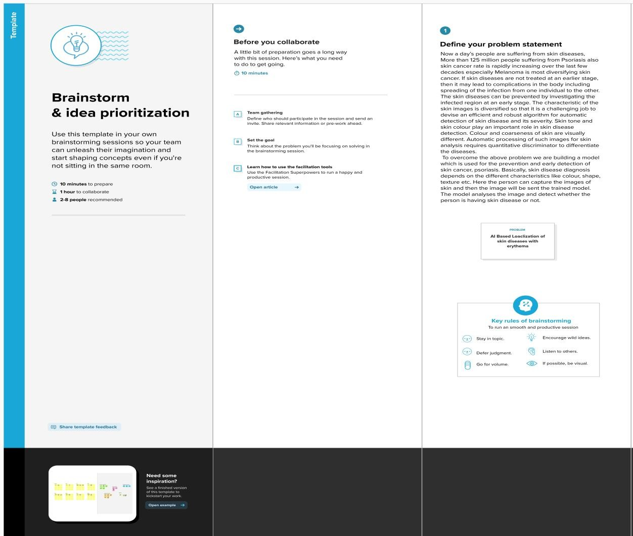

**Step-2: Brainstorm, Idea Listing and Grouping**

-

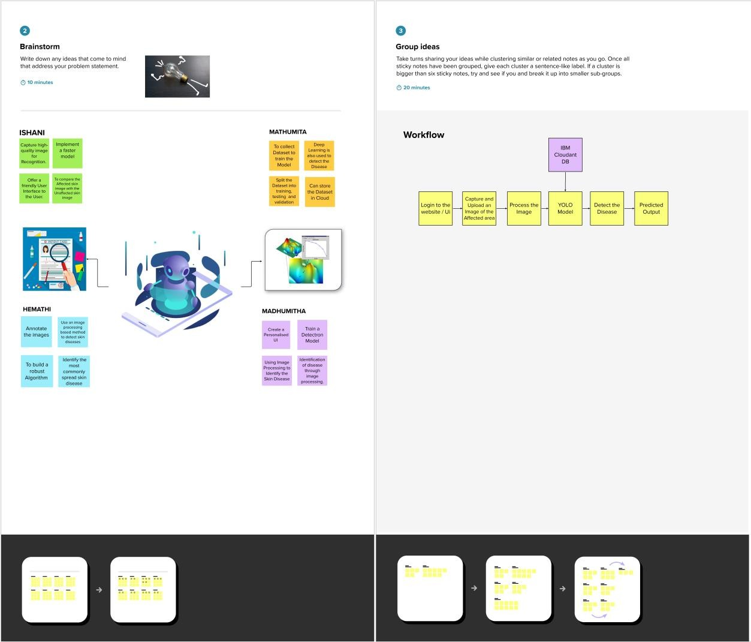

**Step-3: Idea Prioritization**

